# Notes

myRIO pinouts

voltmeter

* Divider red to +V of measure
* Divider black (red side) to GND of measure
* Divider yellow to AI0+ of MSP (C)
* Divider black (yellow side) to AGND of MSP (C)
* Connect resistor across pins AGND and AI0- of MSP (C)

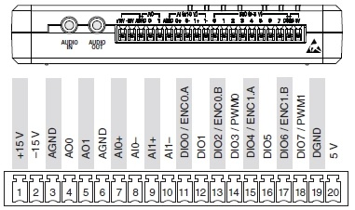

Load cell

* VDD to MXP A pin 33
* VCC to MXP A pin 1
* DAT to MXP A pin 11
* CLK to MXP A pin 13
* GND to MXP A pin 6

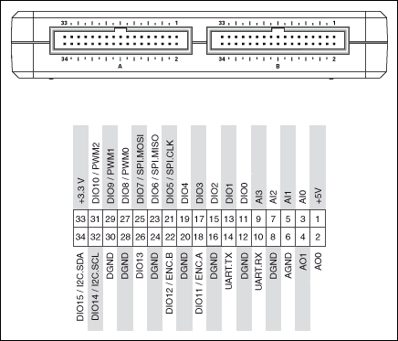

* DAT’s to 11,15,19
* CLK’s to 13,17,21

# TODO

* Joao wants some UI for calibration
* Calibrate the load cells when setup is ready
* Solder all the remaining circuits and test them
* Test the current sensor properly
* Test long wires and its efficacy
* Get the MSP connector add-on from Logan
* Try control the motor off the myRIO

Left and Right contain:

3 load cells

1 voltmeter

1 ammeter

1 light sensor

1 PWM output

Centre contains:

3 load cells

Motor has:

2 motors

The voltage divider currently connected to the myRIO

13.81

1.642

The free voltage divider

13.49

1.642

2 * 820k’s were used for Vout and 2 * 6M8’s were used for dissipation

For the light sensor, it is 71 Ohms before the LED and 5V across whole circuit. 5kOhm between emitter and ground, and 10V across whole circuit. But you need to check the myRIO to see if it can supply enough current for the whole circuit